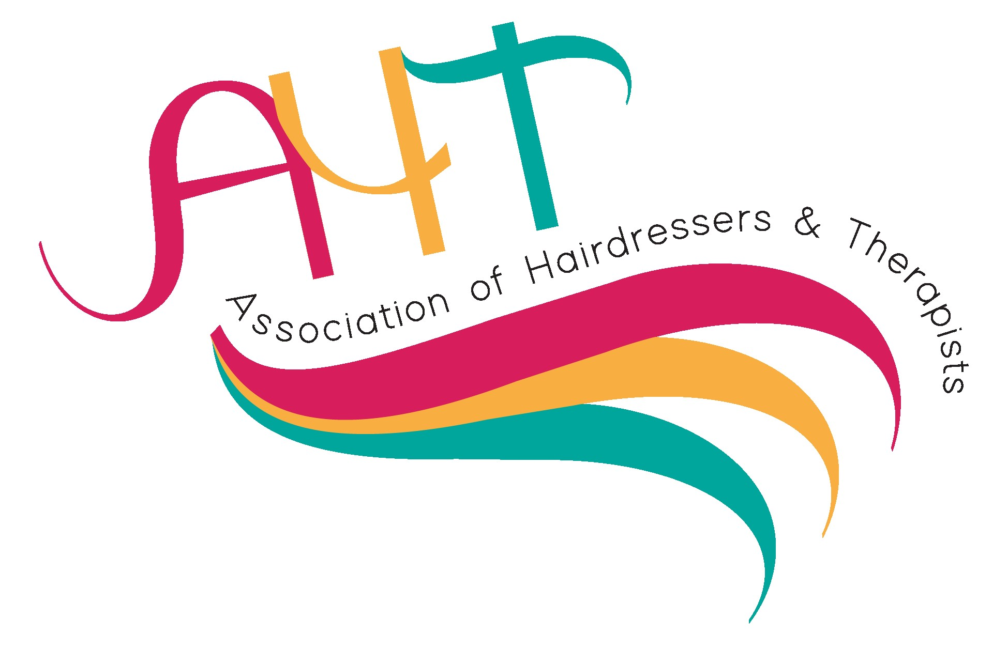
Nomination form for AHT Awards 2025
(closing date for nominations Friday 7th March 2025)
The awards will be presented at the AHT Learning and Development forum Gala Dinner on Saturday 5th April 2025
An overall winner from the 5 categories will be awarded by Andrew Barton
Nominated By:  Full name |  | Nominee Details:
Job Title
Centre and address
Email Address
Please tick category you are nominating for (choose only one):
Award Number | Award Title | Sponsor | Category
1 | Supporting the training of Apprentices to achieve a successful outcome.  This award acknowledges and celebrates a college or training provider’s exceptional contributions to the apprenticeship programmes in the hairdressing, barbering and beauty sector. To include delivery, end point assessment and outcomes. | HABIA
2 | Showing outstanding employer engagement.  For this award tell us about partnerships and links that have been developed within the industry and employers. Also, initiatives for staffing CPD opportunities. | Dermalogica
3 | Demonstrating excellent support for students/trainees.  This award is for an individual that prides themselves on the support that they have given to the students and learners. Describe ways in which they have helped and inspired learners, and how the learners have progressed through the support they have been given. | CENGAGE
4 | Excellent individual tutor/trainer of the year.  This award is for teachers or lecturers who have gone beyond their job role in inspiring all students and learners to reach their potential. They always deliver exciting high-quality teaching, inspiring their students or learners. | VTCT
5 | Exceptional teamwork  Tell us how the team has impacted on students and learners and their lives; describe the work the team have done to enable students and learners to achieve their goals and ambitions. | City & Guilds

Please return your submission by 7th March, with no more than 500 words on a word document electronically to:

Denise Johnson at: DJohnson064@hotmail.com

